- A logistics company uses a queue data structure to manage the order ofprocessing packages at their sorting center. Each package is identified by aunique code represented as an integer. Due to a system update, the company needs to reverse the order in which the packages are processed without changing the sequence of processing for any new packages that arrive after the reversal. The task is to implement a system that enqueues package codes, prints the original processing order, reverses the queue, and then prints the reversed processing order.

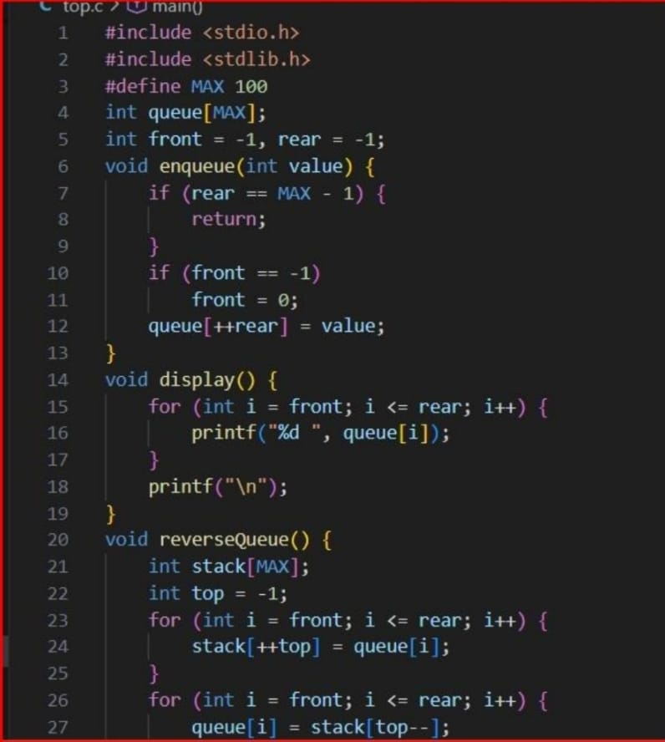

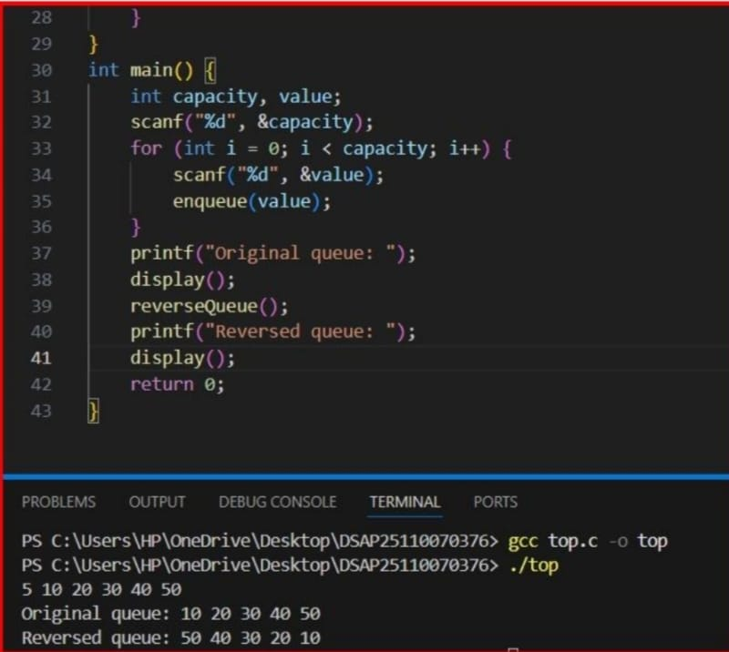

- John is tasked with creating a program to manage student roll numbers using a singly linked list. Write a program for John that accepts students&#39; roll numbers, inserts them at the end
of the linked list, and displays the numbers.

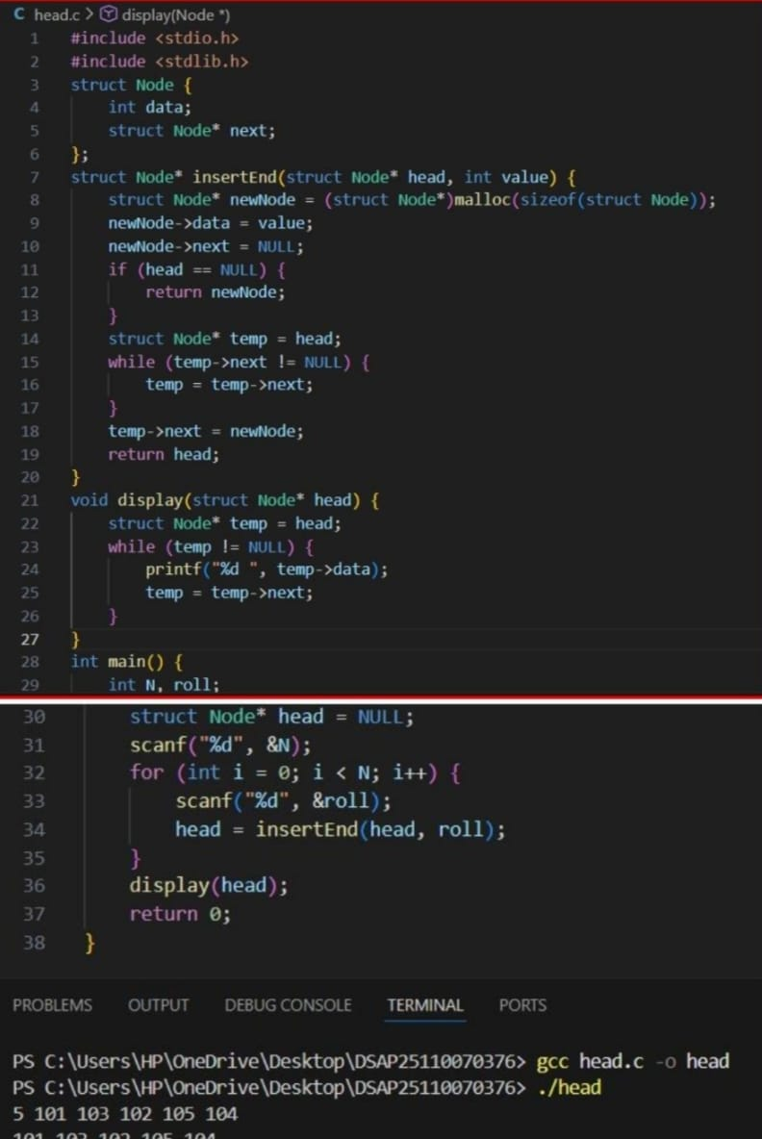

- Arun is tasked with implementing a program to reverse a singly linked list. The program should populate the list elements by inserting them at the beginning, traverse the list and reverse the order of its elements. Since Arun is new to programming, you have to guide him through the task.

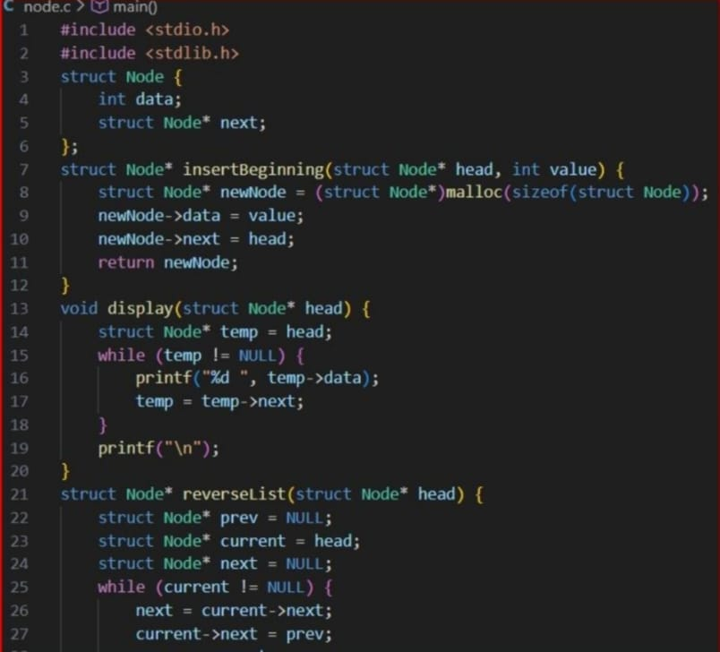

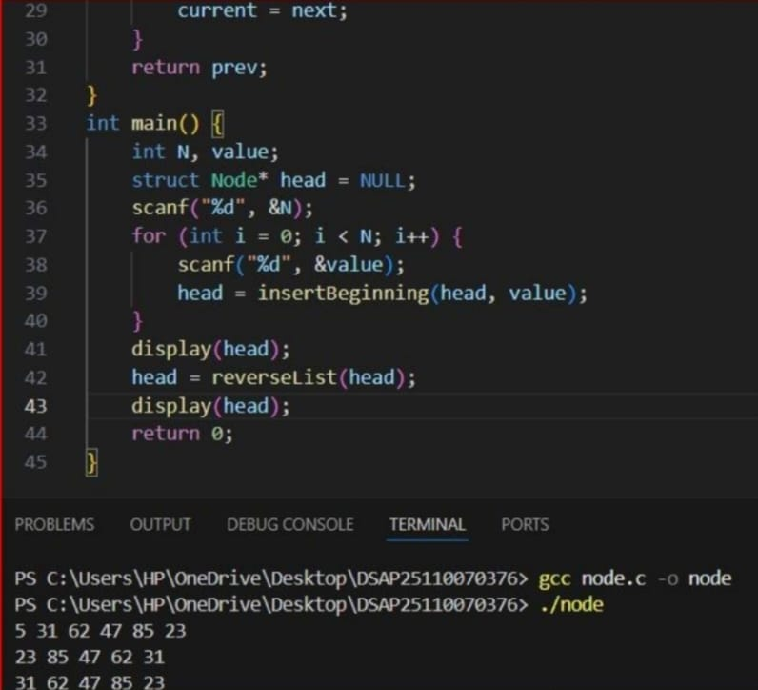

- Dev is tasked with creating a program that efficiently finds the middle element of a linked list. The program should take user input to populate the linked list by inserting each element into the front of the list and then determining the middle element. Assist Dev, as he needs to ensure that the middle element is accurately identified from the constructed singly linked list:If it is an odd-length linked list, return the middle element.If it is an even-length linked list, return the second middle element of the two elements.
